Tutorial 7
At the end of this tutorial you should be comfortable with the following:-
- Exchanging JSON between client and servlet.
- Setting up a Postgres database and executing SQL commands
- Executing SQL commands from Java

Ex1 Sending JSON Data
In Tutorial 5 exercise 5 we created a two-way communication channel to send data from the client to the server in the body of a POST request and have the server issue a response including data.
Using this technique we can instantiate an object at one end, encode its fields in JSON format, send it to the other end via a POST request or response and instantiate and initialize an identical object at the other end. Google luckily make a very easy to use library called GSON for encoding objects into JSON strings.

- Add a line in the dependencies section of build.gradle for both the client and the server as follows, to include the gson library:-
implementation group: 'com.google.code.gson', name:'gson', version: '2.7'
(remember to refresh the Gradle task window)
- Add a Patient class to both your client and servlet – it should have fields such as name, id, contactNumber.
- In your client makePostRequest method, before the http POSTing code, instantiate an object p of class Patient and initialize its fields with some example values.
- Add the following after the instantiation:-
Gson gson = new Gson();
String jsonString = gson.toJson(p);
- jsonString is now a text representation of the fields in p and their values – have a look at it, or println it to the console to see how JSON encodes the fields and their values. Send this to the servlet instead of the Hello Servlet message of Tut5 Ex5.
- In the servlet doPost method, do the following with reqBody after it has been read:-
Gson gson = new Gson();
Patient p=gson.fromJson(reqBody,Patient.class);
- Run the servlet and the client – the servlet should now have created an object of class Patient which has exactly the same field values as the object in the client. Ie we can now send objects from the client to the servlet, and by doing something similar with the response, we can send objects back to the client from the servlet. If you are putting JSON in the response body, make sure to set the appropriate response content type to indicate that the body is JSON:-
resp.setContentType("application/json");


Ex2 Setting up Postgres database tables
- Install a Postgres database locally on your machine https://www.postgresql.org/download/ (write down or remember the password you use when setting it up)
- Open IntelliJ and select View->Tool Windows->Database
- In the database window, click the plus button and add a data source of type PostgreSQL and use the following values host:localhost, user:postgres, password:whatever you set when installing postgres, Database:postgres.
- Click Test Connection and it should be successful. Click OK and in the database window you should see your database connection tree.
- Click the QL icon at the top of the database window->New Console
We can now enter SQL (Structured Query Language) commands in the main console that has appeared. SQL is the common language of databases, although there are slightly different dialects depending on the specific database. We are using the Postgres dialect.
- We will create a new table in the database that stores patient information. A table is like a spreadsheet which has columns for different fields, and the rows contains the values for each patient. Enter the following SQL in the console window and then click the go button (play button top left of console window):-

create table patients (
id SERIAL PRIMARY KEY,
familyname varchar(128) NOT NULL,
givenname varchar(128) NOT NULL,
phonenumber varchar(32)
);

This creates an empty table called patients with four columns – id, familyname, givenname, phonenumber. Each row inserted into the table represents these values for each patient.
- id is declared as type SERIAL, which means an auto-incrementing 4-byte integer, and is a PRIMARY KEY – which means that it is used to uniquely identify each row in the table – no two rows can have the same id even if all other columns are the same. There can’t be more than one primary key column in a table. We don’t have to set this column explicitly – it will be set by Postgres when we add the other fields.
- familyname and givenname are varchar(128) which means that they are strings of chars with a maximum length defined as 128 chars. The number of chars is our decision. They are both declared NOT NULL, which means that these fields must have a value and can’t be left blank.
- phonenumber is a string of maximum 32 chars which is optional and can be left blank – ie NULL because it is not declared as NOT NULL.

Other useful column types in Postgres include:-
integer 4 bytes
bigint 8 bytes
real 4 bytes
double precision 8 bytes
timestamp 8 bytes
date 4 bytes
time 8 bytes
Boolean 1 byte

- We will now insert a row into the table – enter the following in the console and click go:-

insert into patients (familyname,givenname,phonenumber) values('Jones','Bill','07755678899');

Try inserting a few more patients with variations on those names.

Now in the View->Tool Windows->Database you should see something like the following:-
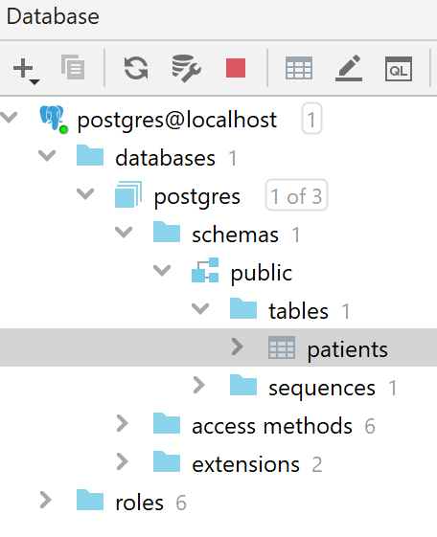
Double click on patients and it should show you the actual table filled with data, something like:-
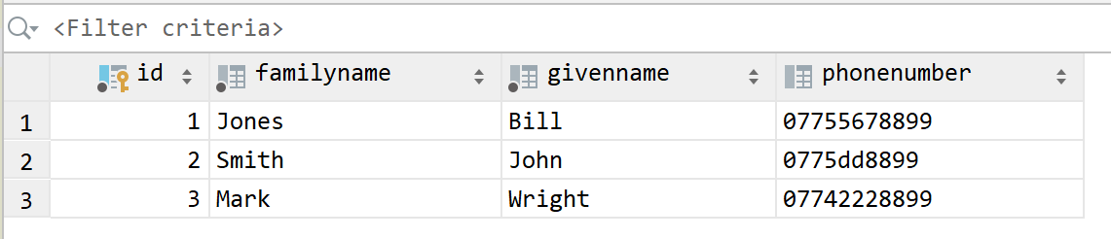

Note that the id in the first column has auto-incremented.
- We will now try querying the table – enter the following (choose givennames that you’ve inserted in your table!):-

select phonenumber from patients where givenname='Bill';

You should see a result like:-
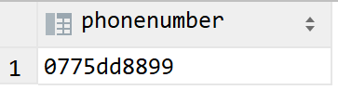

Now try:-
select * from patients where givenname='Bill';

You should see a result like:-

Here are some more SQL queries to try one at a time:-
select phonenumber, id, givenname from patients where givenname!='Bill';
select * from patients where id >= 2;
select * from patients where givenname in ('John','Bill');

- Now try editing table entries – run these commands one at a time:-
select * from patients where id=1;
update patients set phonenumber='+4476886379' where id=1;
select * from patients where id=1;
update patients set phonenumber='+4472222479' where givenname='Bill';
select * from patients where givenname='Bill';

- Now create another similar table: ‘doctors’ which has the columns id, familyname, givenname, pagernum, and add some entries.

Ex3 Joining Tables
We will now create a linking table that indicates which doctor treats which patient.
- Create the following table:-
create table patientofdoctor (
id serial primary key,
patientid int NOT NULL,
doctorid int NOT NULL
);

- Insert the following values:-
insert into patientofdoctor (patientid,doctorid) values (1,2);
insert into patientofdoctor (patientid,doctorid) values (2,2);
insert into patientofdoctor (patientid,doctorid) values (3,1);

The patientofdoctor table should now look like this:-
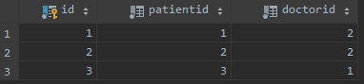

These entries are saying that doctor id 2 treats both patient id 1 and patient id 2, and doctor id 1 treats patient id 3

- Now try the following – this requires some concentration to understand! :-
select * from patientofdoctor inner join patients on(patients.id=patientofdoctor.patientid)
where doctorid=2;

You should get something like:-

This is called a table join. It shows the data of all patients treated by doctor 2.
This instruction searched for each row in patientofdoctor where doctorid=2, and then joined the appropriate row from patients to the right hand side of it.
It chose the appropriate row from patients by using (patients.id=patientofdoctor.patientid)

- This next command also joins the doctors table to patientofdoctor and patients – but does not select all columns to display from the resulting table join:-
select patients.familyname, doctors.familyname from patientofdoctor
inner join patients on(patients.id=patientofdoctor.patientid)
inner join doctors on(doctors.id=patientofdoctor.doctorid)
where doctorid=2;

Which gives a result something like:-
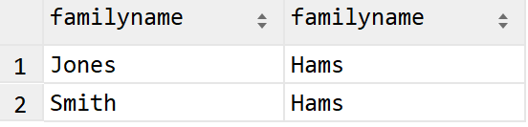

Ex4 SQL Queries from Java
Java has libraries to help you make SQL queries to databases. To add the Postgres database driver library, add the following as a dependency to build.gradle:-
runtimeOnly group: 'org.postgresql', name: 'postgresql', version: '42.2.18'

To connect to a database on your local machine, here is an example of the code for SQL instructions
Firstly, the connection details:-
String dbUrl = "jdbc:postgresql://localhost:5432/postgres";
try {
// Registers the driver
Class.forName("org.postgresql.Driver");
} catch (Exception e) {
}
And for this next line, use the username and password from step 3 of Ex2
Connection conn= DriverManager.getConnection(dbUrl, "postgres", “password”);

After this connection has been made, this following code executes instructions that don’t return results – such as insert, update, create table etc:-
try {
Statement s=conn.createStatement();
String sqlStr = "INSERT INTO patientofdoctor (patientid,doctorid) values (1,2);”;
s.execute(sqlStr);

sqlStr = "INSERT INTO patientofdoctor (patientid,doctorid) values (2,2);”;
s.execute(sqlStr);

s.close();
conn.close();
}
catch (Exception e){
}

Here is an example for SQL instructions that do return results:-
try {
Statement s=conn.createStatement();
String sqlStr = "SELECT * FROM patients WHERE id>1;”;
ResultSet rset=s.executeQuery(sqlStr);
while(rset.next()){
System.out.println(rset.getInt("id")+" "+ rset.getString("familyname"));
}
rset.close();
s.close();
conn.close();
}
catch (Exception e){
}

Starting with the code examples above, try the exercises from Ex2 using a Java app instead of the console window.

Tsuru
Note: if this code is running on Tsuru, a Postgres database has been setup for your app and the URL is made up from environmental variables as follows:-

String dbUrl = "jdbc:postgresql://"+System.getenv("PGHOST")+":"+System.getenv("PGPORT")+"/"+System.getenv("PGDATABASE");

And login with:-
conn= DriverManager.getConnection(dbUrl,System.getenv("PGUSER"),System.getenv("PGPASSWORD"));

Heroku
Note: If this code is running in a servlet on Heroku, replace dbUrl above with the following environmental variable that Heroku configures for you to use the native Heroku installation of Postgres:-
String dbUrl = System.getenv("JDBC_DATABASE_URL");

And then password and username are not needed for the connection:-
Connection conn= DriverManager.getConnection(dbUrl);


Ex5 Further Git - Modifying Hello, World!
We are now going to do a role play with your program and Git for a very common scenario. Create an app that prints ‘Hello, World!’ to the console, and create a remote repo (VCS->Share Project on Github). This creates a single branch called the master branch and pushes it to github (you can see this indicated in the bottom right hand corner of IntelliJ). Tag this as v1.0 (Git->Tag) and push to Github again (making sure to check ‘Push tags’ on the push window)
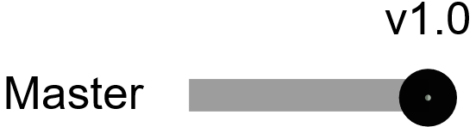

The role play action will take place as follows:
v1.0 has been shipped to the customer, and they are getting good sales and are very pleased with the way it displays Hello, World!.
You are to start work on an update called v1.1, and the customer has provided three user requirements – read them and then start on step 1 below:-

- The program should continue to print “Hello, World” as before
- It should also print the integers between 1 and 10 inclusive, (note System.out.println can take an integer as a parameter) then
- It should calculate and print the sum of all integers from 30 to 40.
Do:-
- Create a branch on which to develop the new version (call it, say, v1.1_devel) Git->Branches->New Branch. This will also change your local repo so that any work you now do is on the new branch. The currently active branch is shown in the bottom right corner of IntelliJ.
- Start work on ver1.1, and complete requirement B, compile and run your code to check it.
However – the customer has just phoned and it’s an emergency! Their competitor’s program prints “Good Morning, Universe!” instead of “Hello, World!” and this program should do the same immediately – this requires a quick turnaround so that the competitor doesn’t take their customers!
As you are halfway through v1.1, you haven’t got time to complete it, test it and train the customer with the new functionality - you need to make a quick update to the previous code of v1.0.
Do:-
- Add, commit and push the changes that you have made so far to branch v1.1_devel. If you check on github you will see that the new branch exists.
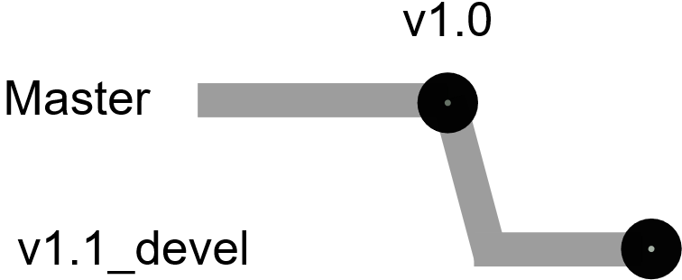
- Switch back to the master branch (Git->Branches->master->checkout, or the same from the indicator at the bottom right of Intellij). You should now see the previous version of the .java file in your editor.
- Change the message to Good Morning, Universe!
- Build and run to test it.
- Commit the changes, tag it as v1.0-ud1 and then push the new code and the tag. (If the Git menu doesn’t appear, click VCS->Integrate with Source Control)

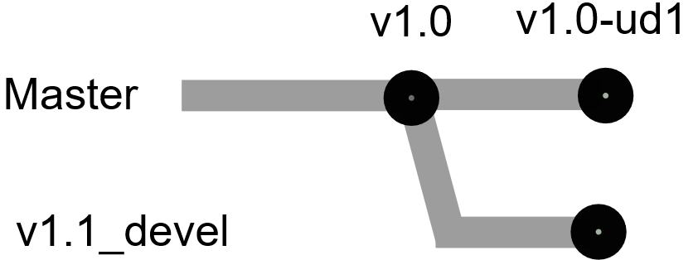

- Now switch back to the v1.1_devel branch Git->Branches-> v1.1_devel->Checkout, and finish user requirement C. Build it, check it works, commit and push it.
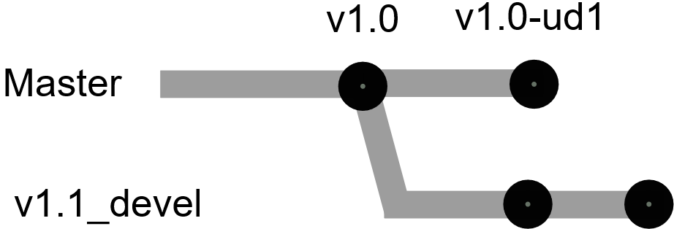
- You have now finished development of v1.1 and must merge v1.1 back into the master, but should also include the changes made in update 1. To do so, switch back to the master branch and then merge the v1.1 branch with Git->Branches->v1.1_devel->Merge into .
- As changes have been made to the same source file on both branches you will be prompted to choose from three options – choose the master version, or choose the v1.1_devel version, or manage the code merge. You will do the latter - click the merge button. You will get a merge dialog box – the two versions on each side, and the middle box for the required outcome. Fix the conflicts between the two different versions (there are >> buttons to choose the code from each side).
- Build and test your program, then commit it, then tag it v1.1.

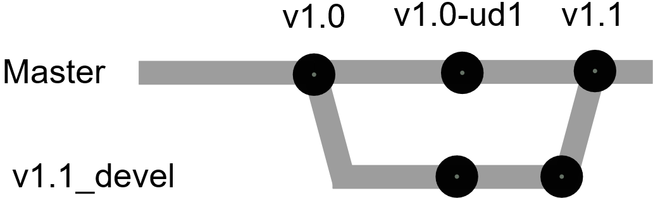

- Now – if you want - you can delete the v1.1_devel branch, or you can keep it in case you need to go back to it at a later stage. Then push to Github


Ex6 Collaboration

Get together with a course-mate and try some of the following exercise – make sure you understand what is going on.
- Collaborate on the Github remote repo that one of you created for the previous exercise – you can add a collaborator from Github: Settings->Manage access->Invite a collaborator
- The customer has the following requirements for v1.2:-
  - The program must do what it already did in v1.1.
  - The program must then print the factorials of integers from 1 to 5.
  - The program must print 1.4 to the power n for integer n from 1 to 5.
  - The program must print “Goodbye, Universe!”
- The newly joined collaborator should clone the Github repo locally on their machine (you can open a cloned repo in IntelliJ as a project
- You are going to split the work between you. Each create different branches that aren’t the master to work on – one of you code 2b., and the other code 2c. and 2d on your separate branches.
- When your tasks are finished – don’t merge with the master locally but push your working branch to Github.
- You each want your changes to be approved by the other and accepted into the code master branch. One at a time, each do the following:-
  - From the Github Pull Request tab, create a New Pull Request from your branch into the master – eg:-
You can add a message with the request, and Github will email your collaborator, informing them of the request.
  - The other collaborator can now view the pull request, which will be visible from the Github ‘Pull Request’ tab. They can approve the request and merge the code into the master branch from Github.
  - The collaborator who approved the change can then Pull the new version of the master branch to their local repo.

